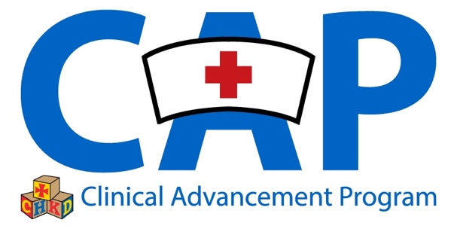

**CURRICULUM VITAE - RENEWAL**

A curriculum vitae (CV) differs from a resume in that it constructs a professional and scholarly identity of an individual through a detailed chronological running list of one’s life accomplishments. As such, the CV as a living document that will need to be updated frequently. A resume in contrast, is a concise introduction of experiences and skills as they relate to a position one aims to acquire.

INSTRUCTIONS:

**Bullet** your entries under each heading using a chronological format. Include formal degrees obtained, educational institutions, certifications, any positions held and emphasize responsibilities and achievements. Most recent accomplishments listed first. All information should be current. An example of the professional objective has been provided. Update accordingly. If a section does not apply, it may be removed.

**NAME AND CREDENTIALS**

STREET ADDRESS

CITY, STATE ZIP CODE

CONTACT NUMBER(S)

**PROFESSIONAL OBJECTIVE:** To achieve Clinical Nurse (3/4) at the Children’s Hospital of the King’s Daughters as demonstrated by my involvement in hospital and division level activities that model exceptional leadership in care delivery and evidence-based practice.

**ACADEMIC BACKGROUND:**

**PROFESSIONAL EXPERIENCE:**

**LICENSURE:**

**SPECIALTY CERTIFICATIONS:**

**SKILL CERTIFICATIONS:**

**AWARDS AND SCHOLARSHIPS:**

**MEMBERSHIP IN PROFESSIONAL ORGANIZATIONS:**

**COMMUNITY SERVICE:**

**PROFESSIONAL ACTIVITIES:**

**INSTITUTIONAL COMMITTEES:**

**PRESENTATIONS & INSTRUCTION:**

**CONFERENCES & WORKSHOPS ATTENDED:**

**PUBLICATIONS:**

**RESEARCH EXPERIENCE:**

**PAPERS & POSTERS PRESENTED:**